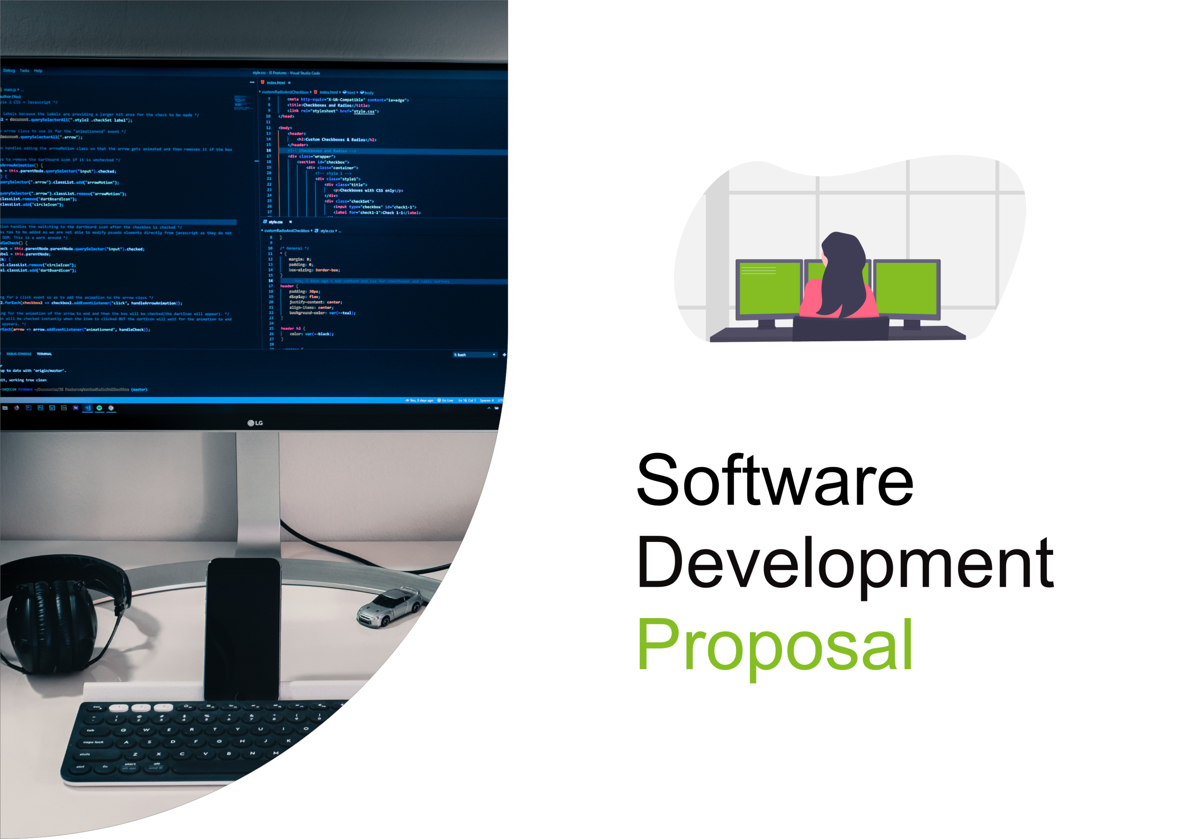

1. Overview

This development proposal outlines the project for creating a private dashboard that provides real-time health status information for the nine machines in each of Daikibo's four factories. The dashboard will be accessible only within the client's intranet and will synchronize authentication with the internal authentication server, allowing users to utilize their company-wide accounts. The primary objective of this project is to provide an intuitive and consolidated view of the current statuses of all monitored devices, while also offering collapsible/expandable views at both factory and device levels, including historical status data.

2. Scope

The proposed private dashboard will be a single-page application designed to display the health status of the machines within Daikibo's factories. Users will be able to access the dashboard within the client's intranet, ensuring data privacy and security. The dashboard will provide a comprehensive overview of the current statuses of all monitored devices. Additionally, the view will be collapsible/expandable at both factory and device levels, enabling users to drill down into specific machines and explore the history of their statuses.

**Please refer to the attached graphics for a visual representation of the proposed dashboard :**

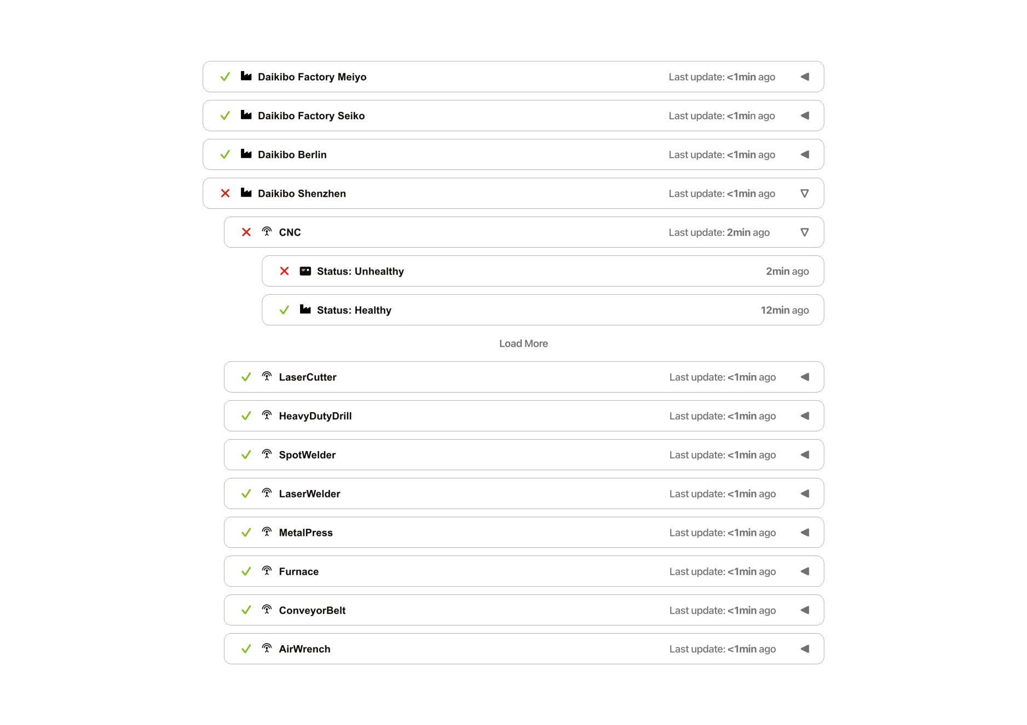

3. Estimate

The estimated man-hours for the development , testing and integration phases are as follows:

**1.Development**

* Front-end development : 30 hours
* Back-end development : 45 hours
* Database design and integration: 10 hours

**2.Testing**

* Unit testing: 5 hours
* Integration testing: 8 hours
* User acceptance testing: 3 hours

**3.Deployment and server setup:** 2 hours

**4.Integration with internal authentication server:** 2 hours

**Total Man-Hour estimate : 120 hours**

4. Timeline

The project will be executed based on the following milestones:

1. Project initiation and requirements gathering: 27th May , 2023
2. Initiation of Designing : 28th May , 2023
3. Design feedback from the Client: 30th May , 2023
4. Final review of the design : 1st June , 2023
5. Development phase: 2nd June , 2023
6. Testing phase: 13th June , 2023
7. Integration phase: 16th June , 2023
8. Final review and deployment: 18th June , 2023

**[The client and the developer will be in consistent contact for feedbacks when necessary or according to the client’s demand.]**

5. Support

Following the completion of the project, our team will provide continuous support to ensure the smooth functioning of the private dashboard. This includes addressing any bugs or issues that may arise, handling support tickets, and accommodating requests for additional functionality or enhancements. Our dedicated support team will be available to provide timely assistance and deliver ongoing product support.